**CryptoDemyth**

- An Online Web-Streaming Service for Crypto Currency Exchanges

**Final Report**



**Information Technology Capstone Project**

COMP5703

Group Members:

1. Can Yang 450042230
2. Nan Meng 450285538
3. Yuanqi Pang 460490911
4. Ziqi Yang 460195418

**School of Information Technologies**

**Faculty of Engineering and Information Technologies**

**The University of Sydney**

**2018**

Table of Contents

Executive Summary 3

1. Introduction 3

2. Background and Related Literature 3

﷟HYPERLINK "bookmark://_Toc517453571" ￼3

﷟HYPERLINK "bookmark://_Toc517453572" ￼4

﷟HYPERLINK "bookmark://_Toc517453573" ￼5

3. Business Requirement Analysis & Use Case 8

3.1 Business requirement analysis 8

3.2 Use case analyse 9

4. Deliverables 14

4.1 Home page 14

4.2 History page 16

4.3 Realtime page 18

4.4 Insight page 21

5. Methodology 23

5.1 Backend & Data access 23

5.2 Frontend 26

5.3 Whale chart 27

5.4 Collaborating methods 28

5.5 Hardware & Software 29

6. Evaluation and Reflection 30

6.1 Evaluation 30

6.2 Reflection 31

6.2.1 Website reflection 31

6.2.2 Project Management reflection 33

Conclusion 34

Reference 35

### 

# Executive Summary

Cryptocurrency is a digital currency which performs the role of medium of exchange, and now it is the field involving pecuniary, cryptography, information technology, and drawing attention from global investors. To trade cryptocurrency, a series of exchanges have emerged, and yet a synthesize website to visualize and analyse the market capitalization and price of numerous cryptocurrencies from different exchanges is still left wanting among many practitioners and stakeholders. Therefore, this project aims to develop a website that analyse current representative exchanges and present comprehensive summary and insights with various types of charts in different time frames.

# 1. Introduction

As cryptocurrency has become more influential in the global economy, there is a substantial demand on the knowledge of diverse exchanges and cryptocurrency protocols. This project is dedicated to delivering a website visualizing comprehensive real-time and historical information of different cryptocurrencies on meticulously designed dashboards. This report presents a brief summarize to the project including user requirements analyse, deliverable and methodologies, along with background and literature review which are focused on chosen cryptocurrency and blockchain. Bitcoin, Ethereum, and Litecoin will consist in the project, review of each cryptocurrency is illustrated in the paper. To implement desired features of this project and provide the engaging user experience, we developed and designed a set of methodologies which uses Django web framework, relational database, serval APIs and correlative programming language. Meanwhile, we also evaluate the work we have done over the semester, detailed evaluations, reflections and future improvements are included in this report.

# 2. Background and Related Literature

## 2.1 Cryptocurrency background

In 2009, Bitcoin was created by an unidentified author named Satoshi Nakamoto, which is the first cryptocurrency ever existed. Ever since Bitcoin's emergence, cryptocurrency have blossomed remarkably, more than 1560 types of cryptocurrencies were developed till now with more than 263 billion USD market capitalization (Coinmarketcap.com, 2018). Basically, a cryptocurrency is a digital currency which performs the role of medium of exchange; meanwhile it is based on cryptography to secure the transactions and to manage the creation of the currency (Chohan, 2017).

Additionally, according to Jan Lansky, as a system, a cryptocurrency has following critical attributes:

1) A centrally managed ledger is not required, it is distributed processed and stored. The system administrated the creation and distribution of cryptocurrency units.

2) Exclusive and cryptographical methods are essential to prove ownership of cryptocurrency units.

3) If the same cryptographic units have two different orders for shifting ownership, the system executes at most one of them (Lansky, 2018)

## 2.2 The Chosen Cryptocurrency Background

1) Bitcoin and the Bitcoin Blockchain

After the dramatic fluctuation change of Bitcoin from 2017 untill now, Bitcoin has drawn the whole world’s attention to itself. Bitcoin is the first decentralized cryptocurrency which represents the biggest market capitalization value (around 114 billion USD) of cryptocurrency market, which constitutes half of the whole cryptocurrency market capitalization (Coinmarketcap.com, 2018). A Bitcoin unit is divisible, the smallest fraction of a Bitcoin is one “Satoshi”, one part per hundred million of one Bitcoin.

The Bitcoin Blockchain is a data file that carries the records of all past Bitcoin transactions, including the creation of new Bitcoin units. It is often referred to as the ledger of the Bitcoin system. The Bitcoin transaction works like this. A broadcast to the network that a seller’s Bitcoin address is the new owner of a specific Bitcoin unit. This information is distributed on the network until all nodes are informed about the ownership transfer.

2) Ethereum

Just like bitcoin, Ethereum is a broadly known and well-developed cryptocurrency, which is also based on a peer-to-peer network protocol consisting of many computers worldwide. Instead of providing users the ability to use a few pre-defined operations (e.g. bitcoin transactions), Ethereum allows its users to run pretty much any code they want. The code is stored on the blockchain for others to interact with and is often referred to as smart contracts.

Compared with Bitcoin, the blockchain is designed for different purposes. In Ethereum, The Ethereum Virtual Machine(EVM) runs as a supercomputer that combines of all computing power of the nodes in the network. This computing power is used to run the user-submitted code (smart contracts) on the blockchain. To execute these, the EVM charges a very small transaction fee in exchange for the computational power used by the smart contract. This fee is called ‘gas’ and it is paid in Ethereum, which is one of the distinguishing attributes makes Ethereum considered as the oil to run the network.

3) Litecoin

Litecoin was released in 2011, and it is an open source, peer-to-peer and decentralized Cryptocurrency that enables instant, near-zero cost transactions. Litecoin is considered as a medium of commerce complementary to Bitcoin. (Litecoin.org, 2018)

The major difference between Litecoin and Bitcoin exist in two perspectives, block processing time and cryptography algorithm. Firstly, to process one block, Litecoin aims for 2.5 minutes while 10 minutes for Bitcoin, which empowers faster transaction confirmation and enhanced storage efficiency. Secondly, Litecoin uses scrypt (a password-based key derivation function) in its working proofing algorithm; therefore, Litecoin mining machine is more complex to deploy and more expensive to operate than Bitcoin SHA-256 algorithm mining machine.

## 2.3 Exchange Background and Current Dashboard Website Review

Since Bitcoin Market, the first Bitcoin exchange, were founded in 2010, there have been over 120 cryptocurrency exchange platforms existed in the market (Sornette & Sanadgol). The team researches major cryptocurrency exchanges (mainly Bitcoin exchanges) and look into the common features of different exchanges (Sornette & Sanadgol).

1) Bitstamp. It is one of the largest bitcoin exchanges. It is originated and centered in the UK. Its security assurance is recognized around the world (Bouri, Molnár, Azzi, Roubaud, & Hagfors, 2017). It provides cryptocurrency exchange information for both USD and EUR.

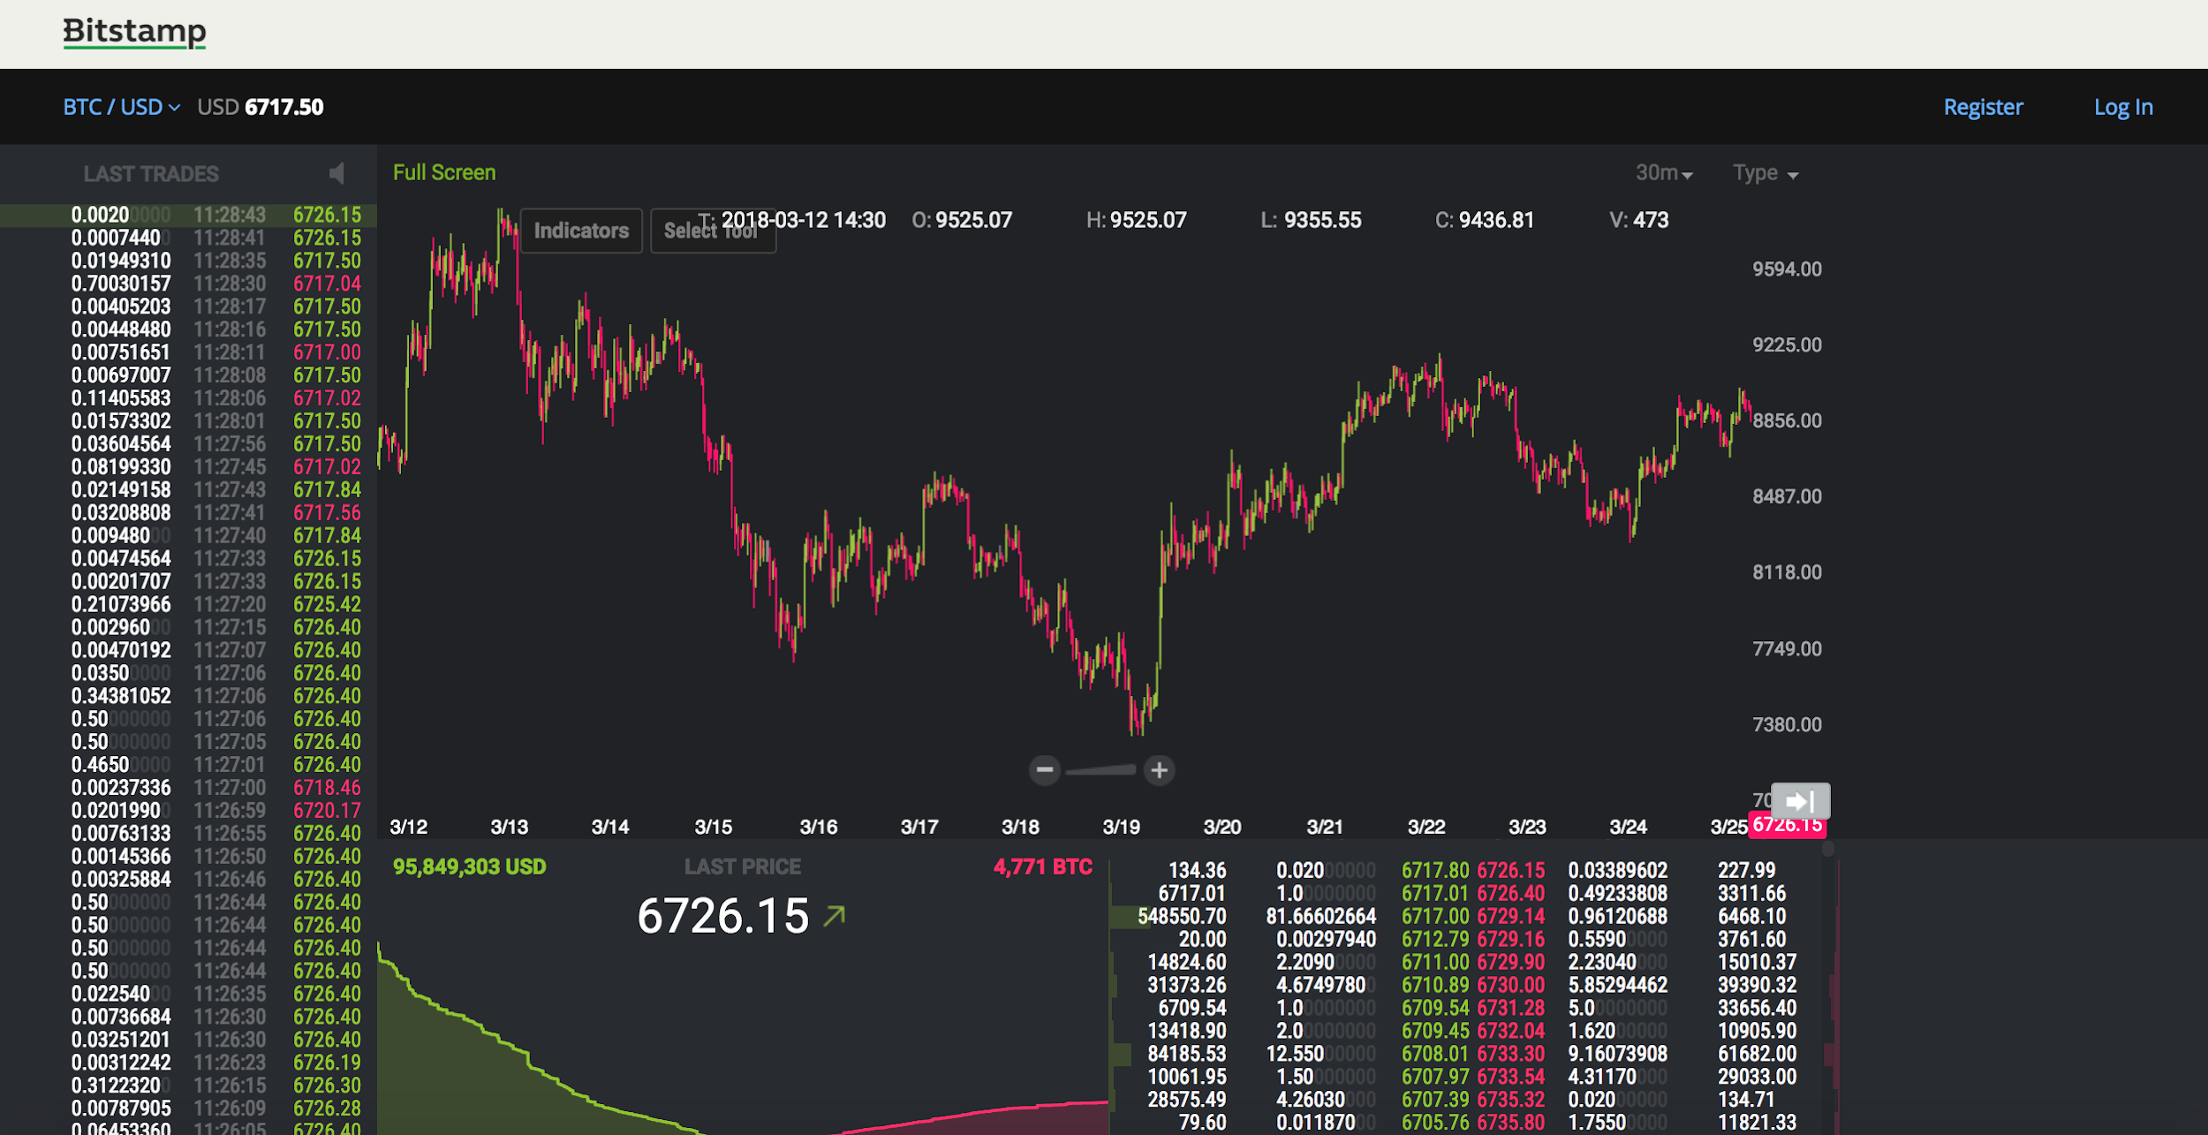

Figure 1 Bitstamp Dashboard

2) Coinbase (GDAX). It is a well-known exchange founded in 2012 and based in the US. It enjoys a good reputation not only because it is available for users from over 32 different countries, but also because it created GDAX in 2014, targeting customers who are professionals in cryptocurrency field (Sornette & Sanadgol). GDAX provides sufficient information of 4 different types of cryptocurrency from 16 markets (Sornette & Sanadgol).

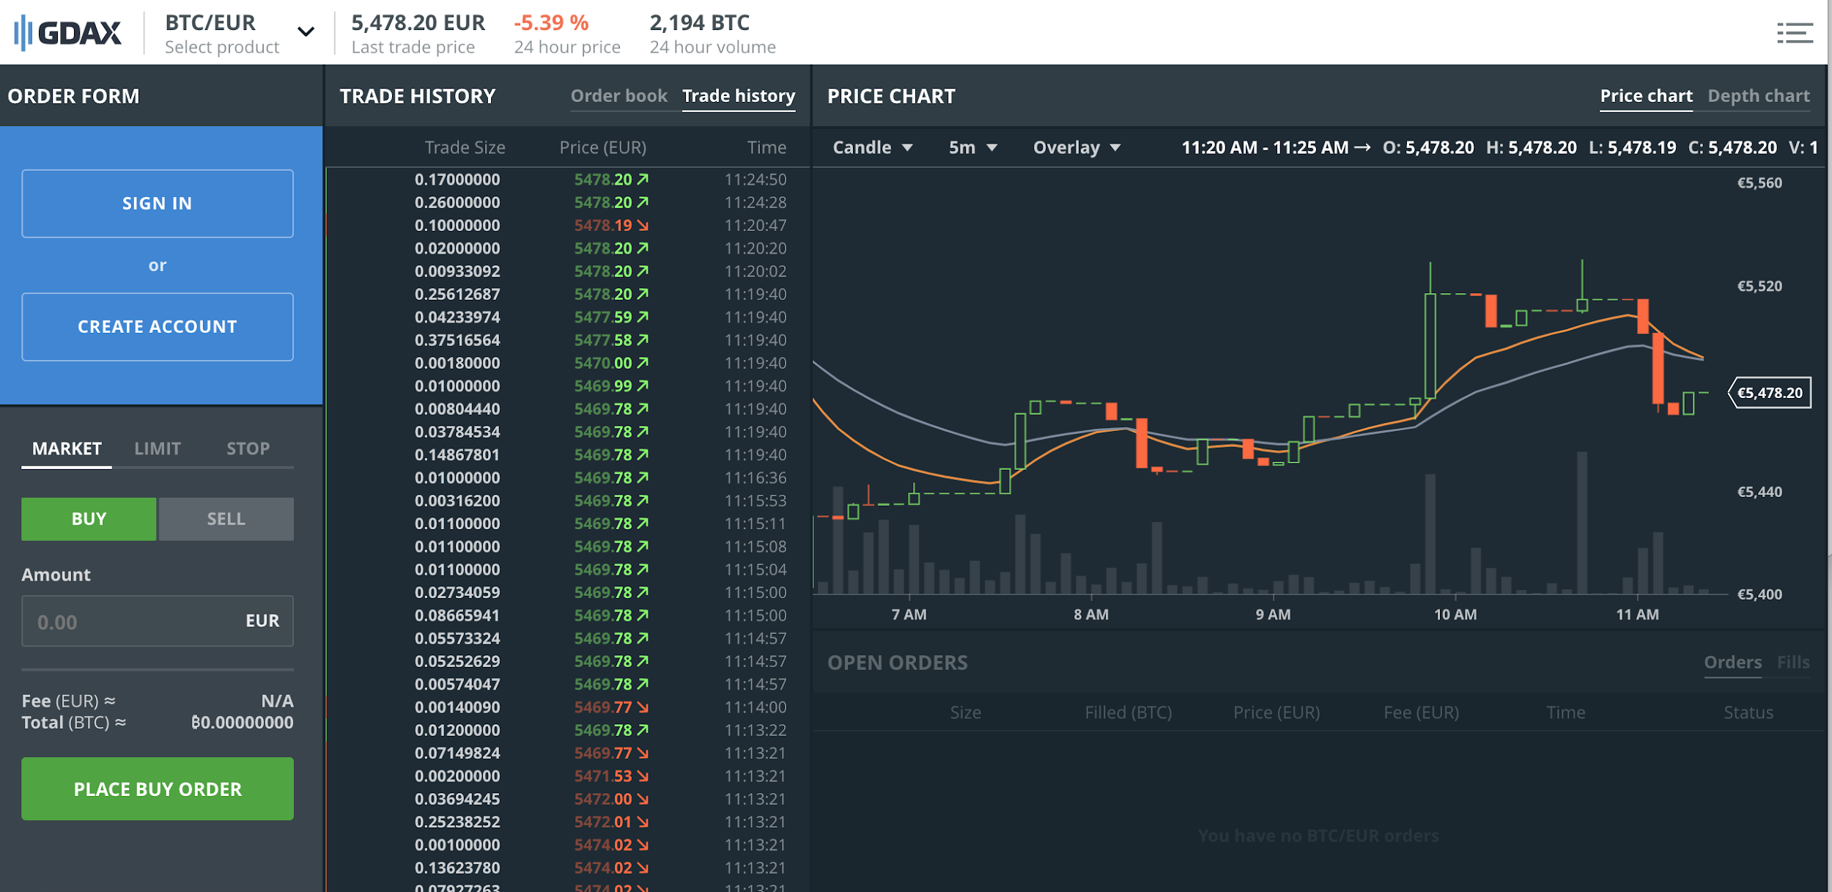

Figure 2 GDAX Dashboard

3) Bitfinex. It is based in Hong Kong and famous for the new way of trading. They allow users to borrow the currency and sell the borrowed currency. Meanwhile, they provide a kind of service which is similar to share options in financial market (Sornette & Sanadgol).

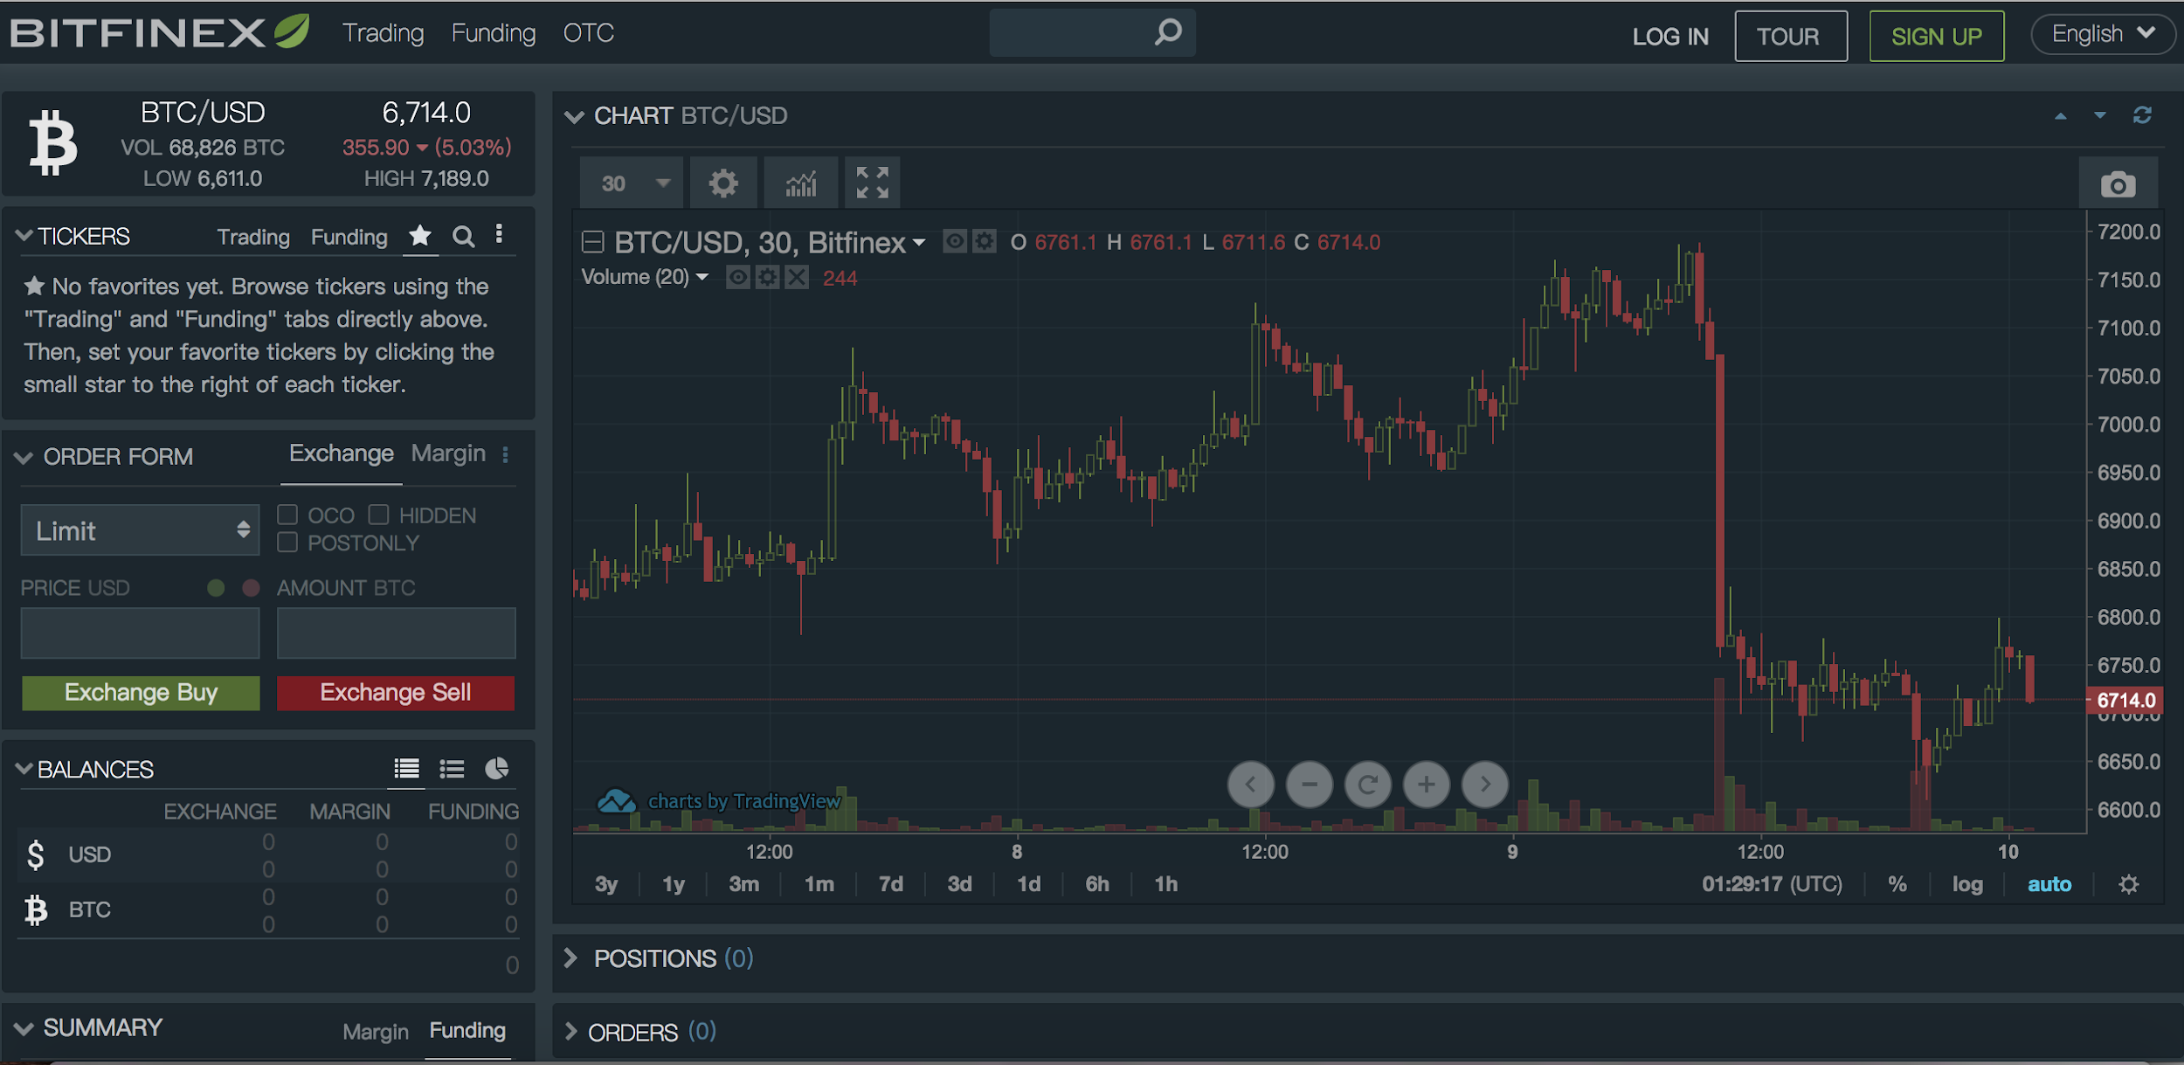

Figure 3 BITFINEX Dashboard

4) Mt. Gox. It used to hold monopoly on Bitcoin market for USD and was regarded as a powerful exchange that can lead the price (Corbet, Larkin, Lucey, Meegan, & Yarovaya, 2017). However, due to significant security issue (hacking), its exchange service was suspended (Li & Wang, 2017). This is a reminder of the important security mechanism in this cryptocurrency data-streaming website.

5) OKCoin. It is established in Beijing and funded by many reliable institutions. It is one of the biggest exchanges in the world and able to exchange between 5 kinds of cryptocurrencies and USD. It is reported by researchers that the Chinese market index might become a main contributor of bitcoin price (Li & Wang, 2017). Therefore, OKcoin is considered to be included in this project’s market data acquisition.

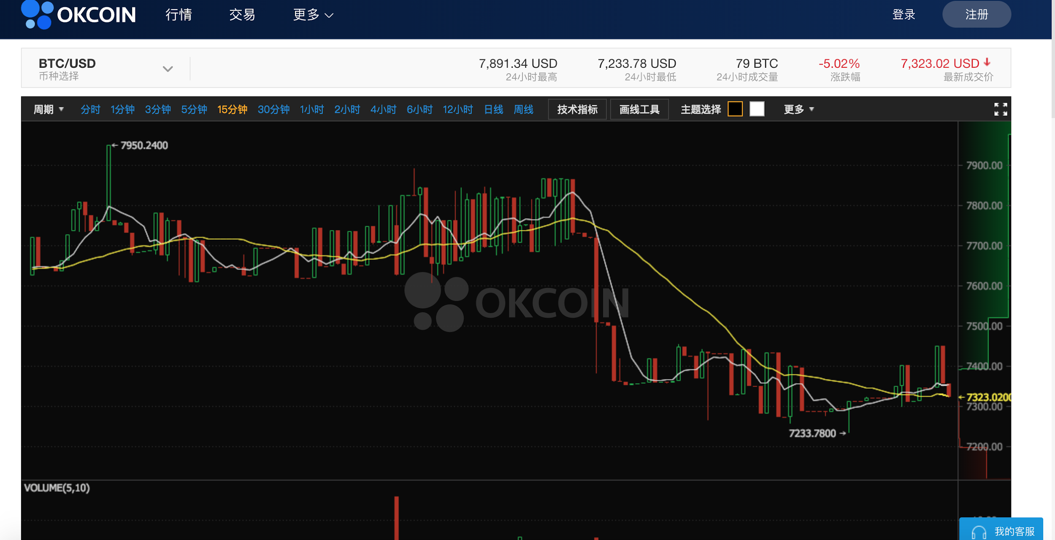

Figure 4 OKCoin Dashboard

All the exchanges mentioned above provide API to connect exchange servers and platforms to our website. There are mainly three ways of connectivity: REST API, WebSocket API and FIX API. WebSocket and FIX API are more efficient connectivity because they only need initial handshake with server to process messages while the REST API requires initiation and termination for every message. Therefore, WebSocket and FIX API are more suitable for copious amounts of real-time data. Nevertheless, FIX API is not as popular in use as WebSocket API, and it is usually used for order placement, which is considered as an extension rather than core function in this project.

# 3. Business Requirement Analysis & Use Case

## 3.1 Business requirement analysis

From the research above, the fact that cryptocurrencies are traded in various exchanges and have different prices could be an obstacle for buyers who are in need of gathering cryptocurrency market performance information easily from different exchanges. For instance, the ask and bid of order book from GDAX and Bitstamp are totally different due to the nature that the orders are created uniquely by users from each exchange. It is important for buyers or sellers to know the current market status from different exchanges so that they can place their order in the correct exchange at the right amount to reach highest profit margin.

Meanwhile, exchanges usually do not put all of their historical data online. For example, in GDAX, one of the largest cryptocurrency online exchanges, users only have the access to the price data from past 1 day (figure 5). Therefore, it is hard for users to analyse and contrast the cryptocurrency market performance in a relatively long timeframe.

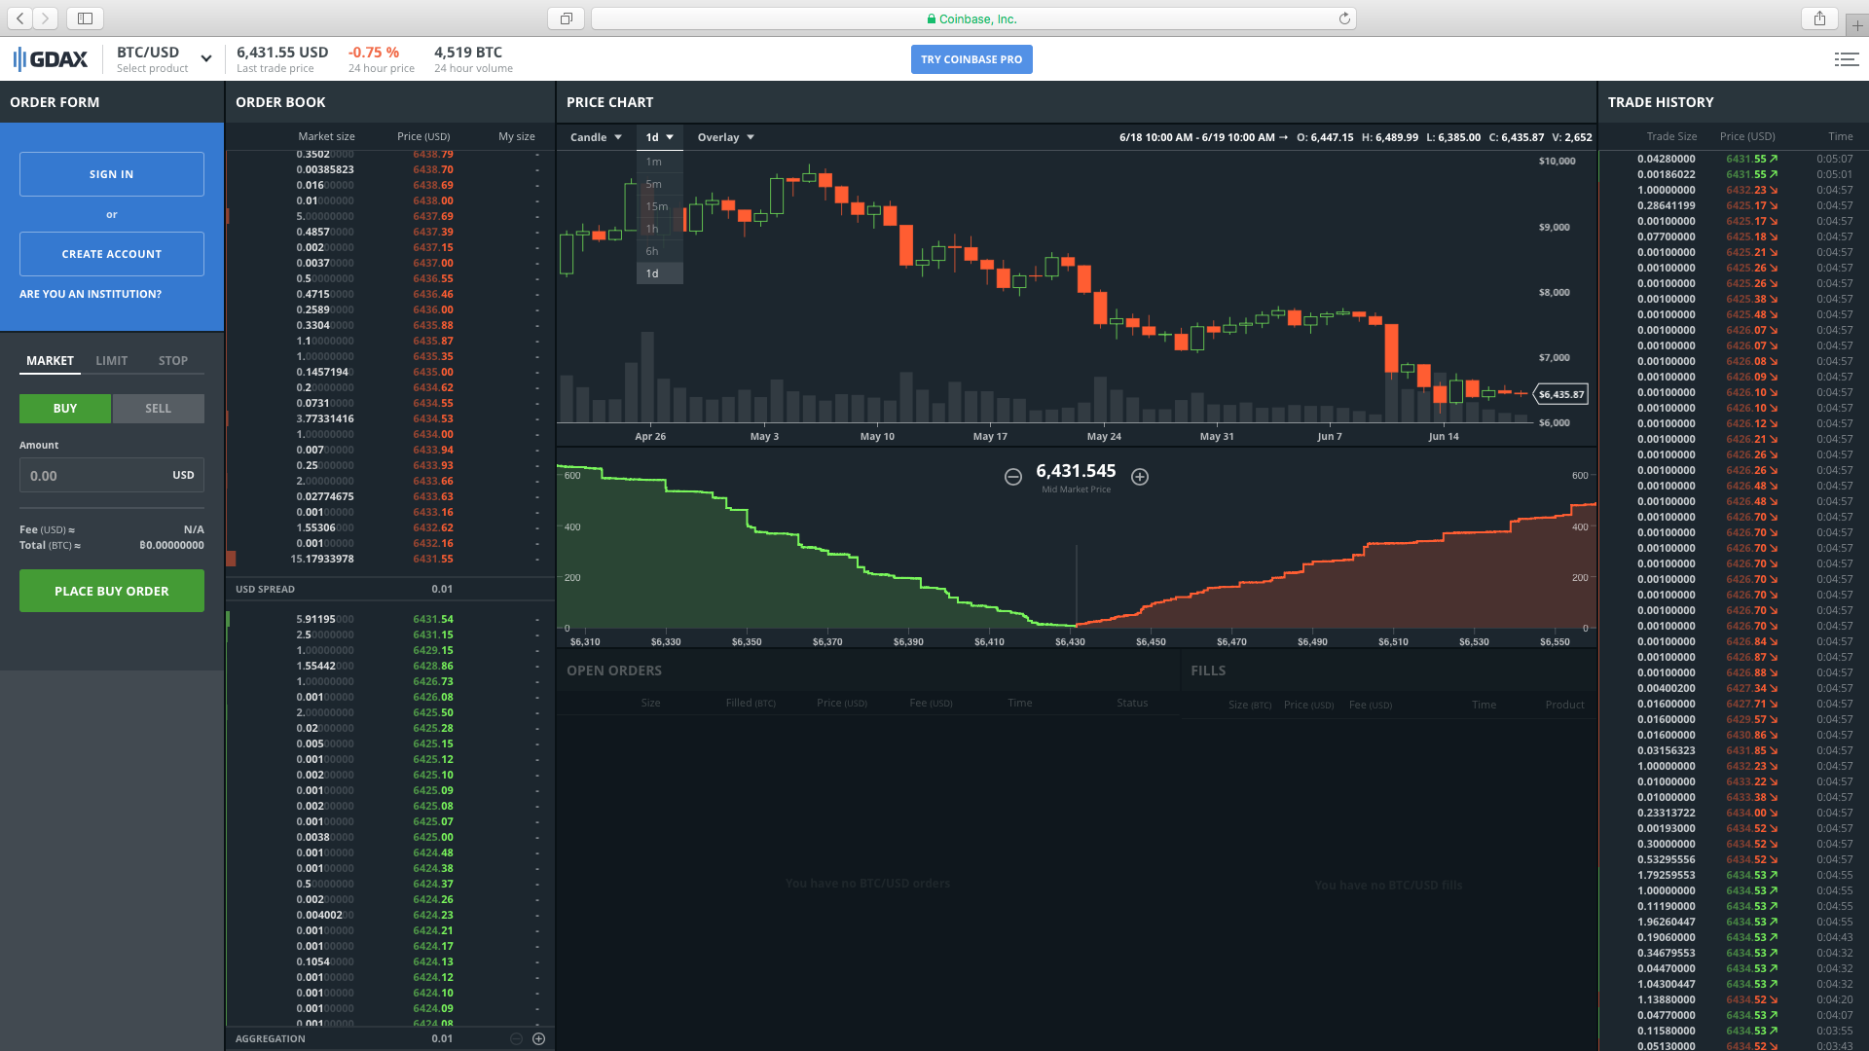

Figure 5 Price chart of GDAX

Hence, the existence of a synthetic cross-exchange data collecting and presenting tool that can demonstrate market performance of different cryptocurrencies from various cryptocurrency exchanges is necessary for addressing this problem.

Since the issue of data accessibility has been solved, the cryptocurrency market performance of different exchanges is available to users. However, it is unlikely to monitor and analyse all the live data only by users. Unlike stock exchanges, cryptocurrencies don’t have open and close, and trades are happening restlessly and globally throughout the day. Market trend of cryptocurrencies is changing in seconds. Surprises may happen anytime, but users only have limited time and energy to deal with it. Thus, an online and real-time analytical indicator which can evaluate significant market such as surge and slump event would assist users to understand current market status without staring at the screen all day.

## 3.2 Use case analyse

In this section, use case analyse would be conducted in a table format, specifying user requirements and designing user interaction with each function of this website. It would also reflect how users are interacting successfully and how things could go wrong for users to achieve the goal.

|  |  |
| --- | --- |
| Use Case | BTC/LTC/ETH dashboard of Homepage |
| Scope and level | Homepage level |
| Pre-condition | 1. Users have connection to internet  2. Users load home page successfully |
| Success end condition | The dashboard runs and refreshes successfully |
| Failed end condition | The dashboard fails to run or refresh |
| Actor | User |
| Trigger | After page loaded |
| Description | It is a dashboard showing the following contents:  Open Hour: the open price of last hour.  High Hour: the highest price of last day.  Low Hour: the lowest price of last hour.  Open Day: the open price of last day.  High Day: the highest price of last day.  Low Day: the lowest price of last day.  Last Trade Volume: last trade volume in cryptocurrency, e.g., 1 bitcoin(BTC).  Last Trade Volume To: last trade volume in USD, e.g., $8000(USD).  24h Volume: the trade volume in cryptocurrency of the last 24 hours.  24h VolumeTo: the trade volume in USD of the last 24 hours.  Total Volume(Cryptocurrency): the total trade volume in cryptocurrency.  Total Volume(USD): the total trade volume in USD. |
| Frequency of use | High |
| Level of risk | Medium |
| Priority | High |

|  |  |
| --- | --- |
| Use Case | Order book of Real-time page |
| Scope and level | Real-time page level |
| Pre-condition | 1. User has connection to internet  2. User loads real-time page successfully |
| Success end condition | 1. Order book displays and refreshes successfully  2. The product selector works. |
| Failed end condition | 1. Order book fails to display or refresh.  2. The product selector works. |
| Actor | User |
| Trigger | After page loaded /product selector |
| Description | List the price and market size based on live orders happening in each exchange |
| Frequency of use | High |
| Level of risk | Medium |
| Priority | High |

|  |  |
| --- | --- |
| Use Case | Real-time candle chart of Realtime page |
| Scope and level | Realtime page level |
| Pre-condition | 1. User has connection to internet  2. User loads real-time page successfully |
| Success end condition | 1. User has connection to internet  2. User loads real-time page successfully  3. The time-frame selector works, which means that the real-time candle chart responds in according user’s selection. |
| Failed end condition | 1. The real-time candle chart doesn’t display.  2. The real-time candle chart doesn’t refresh.  3. The time-frame selector doesn’t work.  4. The product selector doesn’t work. |
| Actor | User |
| Trigger | After page loaded /product selector/time-frame change |
| Description | List the real-time |
| Frequency of use | Medium |
| Level of risk | Medium |
| Priority | Medium |

|  |  |
| --- | --- |
| Use Case | Real-time depth chart of real-time page |
| Scope and level | Realtime page level |
| Pre-condition | 1. User has connection to internet  2. User loads real-time page successfully |
| Success end condition | 1. The real-time depth chart displays and refreshes properly.  3. The real-time depth chart responds to the product selector correctly. |
| Failed end condition | 1. The real-time depth chart doesn’t display or refresh.  2. The product selector doesn’t work. |
| Actor | User |
| Trigger | After page loaded /product selector |
| Description | Show the open, highest, lowest, close prices in different markets in form of candlesticks every 1 minute/ 5 minutes/30 minutes/1 hour, depending on the user's choice. |
| Frequency of use | Medium |
| Level of risk | Medium |
| Priority | Medium |

|  |  |
| --- | --- |
| Use Case | Realtime page product selector |
| Scope and level | Realtime page level |
| Pre-condition | User loads real-time page properly |
| Success end condition | Order book, Depth chart and Candle Chart all respond to the product selector properly. |
| Failed end condition | One of Order book, Depth chart and Candle Chart does not respond to the selector. |
| Actor | User |
| Trigger | After page loaded |
| Description | Enable selection on three pairs of currencies, which are BTC-USD, ETH-USD, and LTC-USD. |
| Frequency of use | High |
| Level of risk | Medium |
| Priority | High |

|  |  |
| --- | --- |
| Use Case | History price candle chart of History page |
| Scope and level | History page |
| Pre-condition | 1. User has connection to internet  2. User loads history page successfully |
| Success end condition | 1. All the components of the chart function properly.  2. Exchange selector functions properly.  3. Product selector functions properly. |
| Failed end condition | 1. One of the components of the chart does not function properly.  2. Failed to retrieve data from database.  3. Product selector or exchange selector doesn’t work properly. |
| Actor | User |
| Trigger | After page loaded/product selector/exchange selector |
| Description | Display the daily open, highest, lowest, and close prices from two exchanges, with the time dimension spaning over the last 300 days. |
| Frequency of use | Medium |
| Level of risk | Medium |
| Priority | Medium |

|  |  |
| --- | --- |
| Use Case | History price comparison of History page |
| Scope and level | History page |
| Pre-condition | 1. User has connection to internet  2. User loads history page successfully |
| Success end condition | 1. All the components of the chart function properly.  2. Product selector functions properly. |
| Failed end condition | 1. One of the components of the chart does not function properly.  2. Failed to retrieve data from database.  3. Product selector doesn’t work properly. |
| Actor | User |
| Trigger | After page loaded/product selector |
| Description | Provides clear comparison of the waving price trend from two exchanges. Detailed information on specific time point displayed when the cursor hover over the chart. |
| Frequency of use | Medium |
| Level of risk | Medium |
| Priority | Medium |

|  |  |
| --- | --- |
| Use Case | Product selector of History page |
| Scope and level | History page |
| Pre-condition | 1. User has connection to internet  2. User loads history page successfully |
| Success end condition | 1. History candle chart and history price comparison chart respond to the product selector. |
| Failed end condition | 1. One of the charts does not respond properly.  2. Failed to retrieve data from database. |
| Actor | User |
| Trigger | After page loaded/product selector |
| Description | Page level control. Enable the different types of cryptocurrencies, i.e. BTC, ETH and LTC. |
| Frequency of use | High |
| Level of risk | Medium |
| Priority | Medium |

|  |  |
| --- | --- |
| Use Case | Whale Chart of Insight page |
| Scope and level | Insight page |
| Pre-condition | 1. User has connection to internet  2. User loads Insight page successfully |
| Success end condition | 1. Whale chart displays and refreshes properly.  2. Whale chart responds to the product selector.  3. Whale chart successfully indicate the suspicious and abnormal market behaviours. |
| Failed end condition | 1. Whale chart doesn’t not display and refresh properly.  2. Whale chart doesn’t not respond to the product selector properly  3. User doesn’t understand the meaning of each indicator. |
| Actor | User |
| Trigger | After page loaded/product selector |
| Description | Use different shapes and colours to indicate anomalies in market or possible purposive interruption to the market. |
| Frequency of use | High |
| Level of risk | Medium |
| Priority | Medium |

|  |  |
| --- | --- |
| Use Case | Product selector of Insight page |
| Scope and level | Insight page |
| Pre-condition | 1. User has connection to internet  2. User loads insight page successfully |
| Success end condition | 1. Whale chart respond to the product selector. |
| Failed end condition | 1. Whale chart does not respond properly. |
| Actor | User |
| Trigger | After page loaded/product selector |
| Description | Page level control. Allow selection on different market and different cryptocurrencies. |
| Frequency of use | High |
| Level of risk | Medium |
| Priority | Medium |

# 4. Deliverables

After 13 weeks’ effort, the team has accomplished all the website functions we proposed. The website consists of four web pages, homepage, real-time page, history page and insight page. Each of them has its own contents and features.

## 4.1 Home page

The homepage provides general and useful information of three types of cryptocurrencies, which are refreshed online and constantly, it includes last market, Trade ID, Open, High, low and trade volume. These terms that are commonly used in the cryptocurrency market, our target users are expected to have a bit related knowledge background; if they don’t, we managed to design the name of the indicators to be intuitive enough to understand and we established help documents for this purpose. Here the details are explained as follows:  
Last Market: The market where the latest trade just happened. Only two markets – Coinbase and Bitstamp are considered.

Trade ID: The latest trader’s ID.

Open Hour: the open price of last hour.

High Hour: the highest price of last day.

Low Hour: the lowest price of last hour.

Open Day: the open price of last day.

High Day: the highest price of last day.

Low Day: the lowest price of last day.

Last Trade Volume: last trade volume in cryptocurrency, e.g., 1 bitcoin(BTC).

Last Trade Volume To: last trade volume in USD, e.g., $8000(USD).

24h Volume: the trade volume in cryptocurrency of the last 24 hours.

24h VolumeTo: the trade volume in USD of the last 24 hours.

Total Volume: the total trade volume in cryptocurrency.

Total Volume: the total trade volume in USD.

Those indicators can give our customers an overall understanding of the daily performance current market in real time, based on which the customers will have a motivation to enter the following pages and further explore the detailed trading information. Therefore, these attributes are chosen in the homepage. Besides, the homepage is decorated with a dynamic background which the customers can interact with using the cursor. The interaction, along with the style of metal aerospace are designed to attract more users and to fit the topic of the website - ‘CryptoDemyth’.

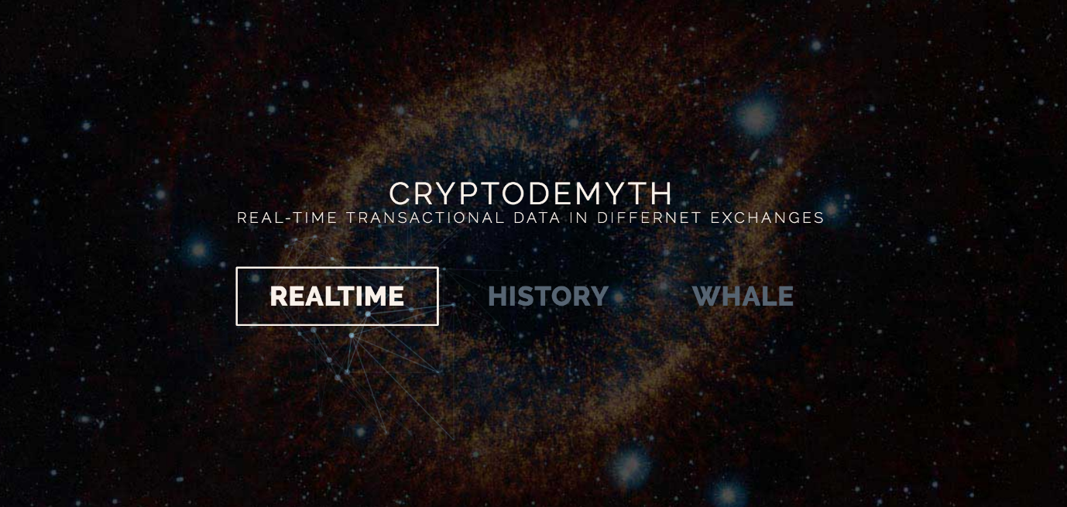

Figure 6 Background of homepage

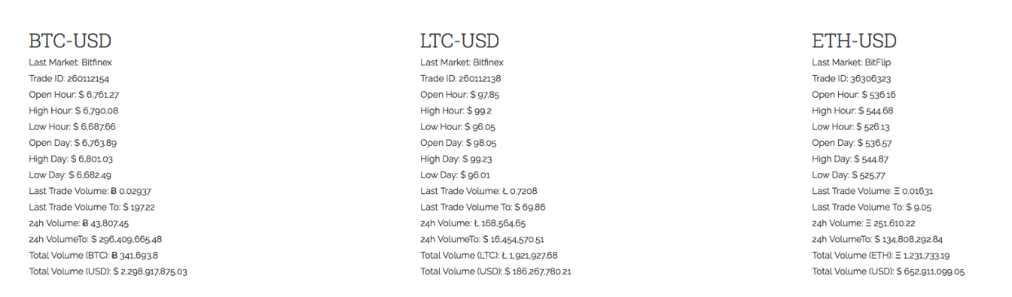

Figure 7 The indicator dashboard

## 4.2 History page

The history page is mainly for comparing the historical trading records in two different markets, Bitstamp and Coinbase. It encompasses the price candlestick chart and the price comparison chart. By using the data requested from exchanges and recorded into local database, both two charts can trace back from yesterday before to the earliest day of the record, so that users can view any day’s data and zoom in/out each chart by dragging the button in the bottom row. As the historical information has a quite long-time span, this page is aimed to provide insights from a macro-perspective. Meanwhile, the database records data on a daily basis. The website refreshes the database every day automatically, the longer this website operates, the more comprehensive the data are.

The history candle chart is designed to show the open price, highest price, lowest price and close price, i.e., ‘OHLC’ information by day. To be more specific, the OHLC refers to “open-high-low-close chart”, it is a type of chart normally used to demonstrate activities in the price of a financial instrument over one unit of time which is 24 hours in this case. By using the exchange and product filter, Users can get a whole picture of the cryptocurrency price in each exchange in the time frame they chose.

Furthermore, the chart provides MA5, MA10, MA20, MA30 lines to assess market trend. MA stands for “moving average”, for instance, MA5 means the moving average of 5 days. MA is a commonly used indicator in technical analysis which assists to smooth out price action by filtering out the “noise” from random price fluctuations. We provided scalable options for different kinds of requirements.

In this chart, we also present the indicators of highest and lowest prices of all the historical data, it displays on the side of the chart and draws 2 dot lines to segment a value area of price. Besides, the overall trend is displayed at the bottom of the chart. It helps users to understand the macro-perspective performance; also, it assists users to find the ideal spot when users control the time-frame.

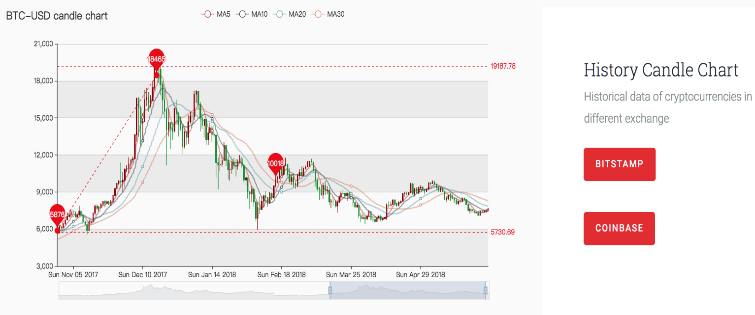

Figure 8 History Candle Chart

The price comparison chart is designed to compare the daily average price of two exchanges. Users are able to quickly locate in the dimensions by moving the cursor in the chart. The price on the date in both markets are illustrated around the line when the cursor is hovering in the chart.

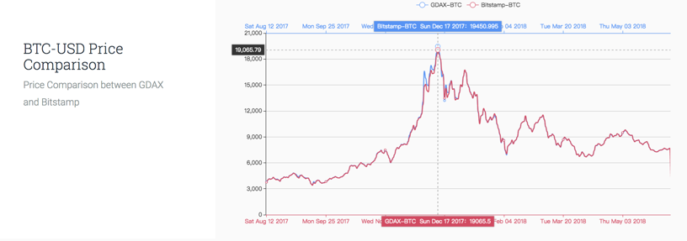

Figure 9 Historical prices comparison

This page is aimed to suit the needs of users who are planning to invest for the long haul. The comparison gives users some hints on the exchange market performance history, and the long-time span information offers evidential reference on when is the best time to enter or exit the market.

In addition, the reason for separating the history rate and real-time rate is that history data do not need to be up to date while the real-time data need real-time updates. Thus, the contents are separated into 2 pages. The history rate page get data from the backend database, and the backend is configured to get the data of the day at 12:00 P.M. and the data displays on the historical candle chart will not include today. The real-time data used in real-time pages are from the web-socket feed API, the frontend get access to the data API and display the information on the real-time page. The data in real-time page requires periodic update, the statics blinking every few seconds. To ensure the update speed and react time of the website, the real-time data are not stored at database.

## 4.3 Realtime page

The real-time page is composed of order book, real-time candlestick chart, and depth chart. All the diagrams work dynamically, and they are based on the latest, ongoing real-time streaming data. The real-time candle chart visualizes the ‘OHLC’information every unit of time. The time unit can be 1minute, 5 minutes, 30 minutes or 1 hour, which can be selected by users as shown in the figure. Also, the chart can zoom in/out by dragging the bottom area of the chart where the price trend is made explicit as line.

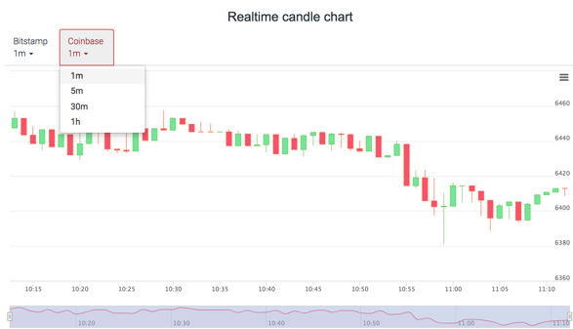

Figure 10 real-time candlestick chart

After the time unit is selected, the data of past 60 units of time will be illustrated. Once per unit of time has passed, one more candlestick will be dynamically added into the chart showing the ‘OLHC’ of last unit of time.

The order book lists the market, price and market size based on live orders happening in each exchange.

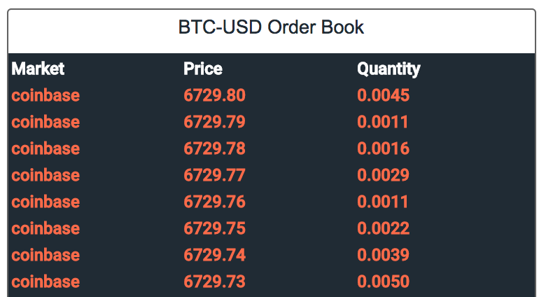

Figure 11 The order book header

An order can be a bid or an ask. Bid is the price offered by buyers while the ask is the price offered by sellers. The underlying logic is started when a new order is made by some trader in the market. Here is an example of a new coming ask. When the new ask comes via the WebSocket API, the system will ‘check’ if there are bids higher than this new ask in the market. If so, the ask will counteract the bids by priorities. To be noted, there are different ways of prioritizing orders in all kinds of order books, some are considering time sequence, account ID type, etc. In this case, we are using the rank of prices. Therefore, among the bids higher than this new ask, the new ask size is starting to counteract the market size of the highest bid first, followed by the second lower one and so on. We chose to use the rank of price because we believe it is fairer. If priority is made by time sequence, then when a buyer waiting in the order book wants to stop the long wait and makes their bid higher, then the time they enter market will be even later. In this case, not as expected, they may have to wait for longer. Besides, for a seller who made the new ask, they would prefer to fill in the deal with the highest price in the current market. For the buyers, as the common rule is that if the bids(asks) is made in advance, you can get no lower (higher) than the price, so in this example, it makes no difference for the buyers. The prices around the gap between the lowest ask and the highest bid provides reference for both sellers and buyers on the order price.

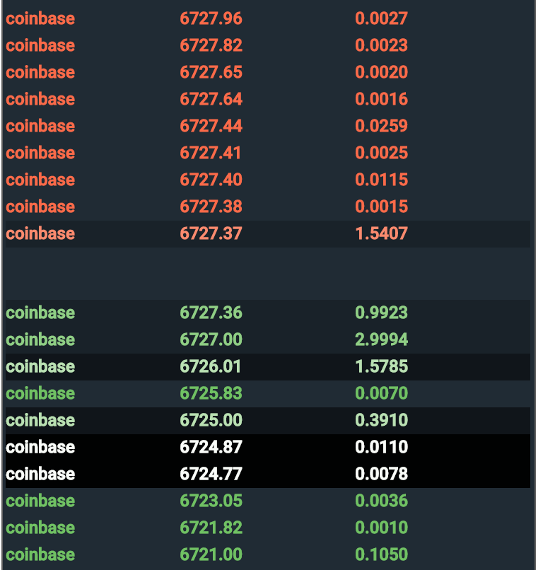

Figure 12 real-time order book body

In the cryptocurrency community, the lack of liquidity is a serious problem, especially when a large amount of bids/asks are made without any response for long (Exchange, 2007). This live order book can improve the liquidity so that the users can make more reasonable orders according to the live information of leading exchanges. According to the given information, the user will be able to better balance the potential opportunity to get a better price, the potential delay in executing the order.

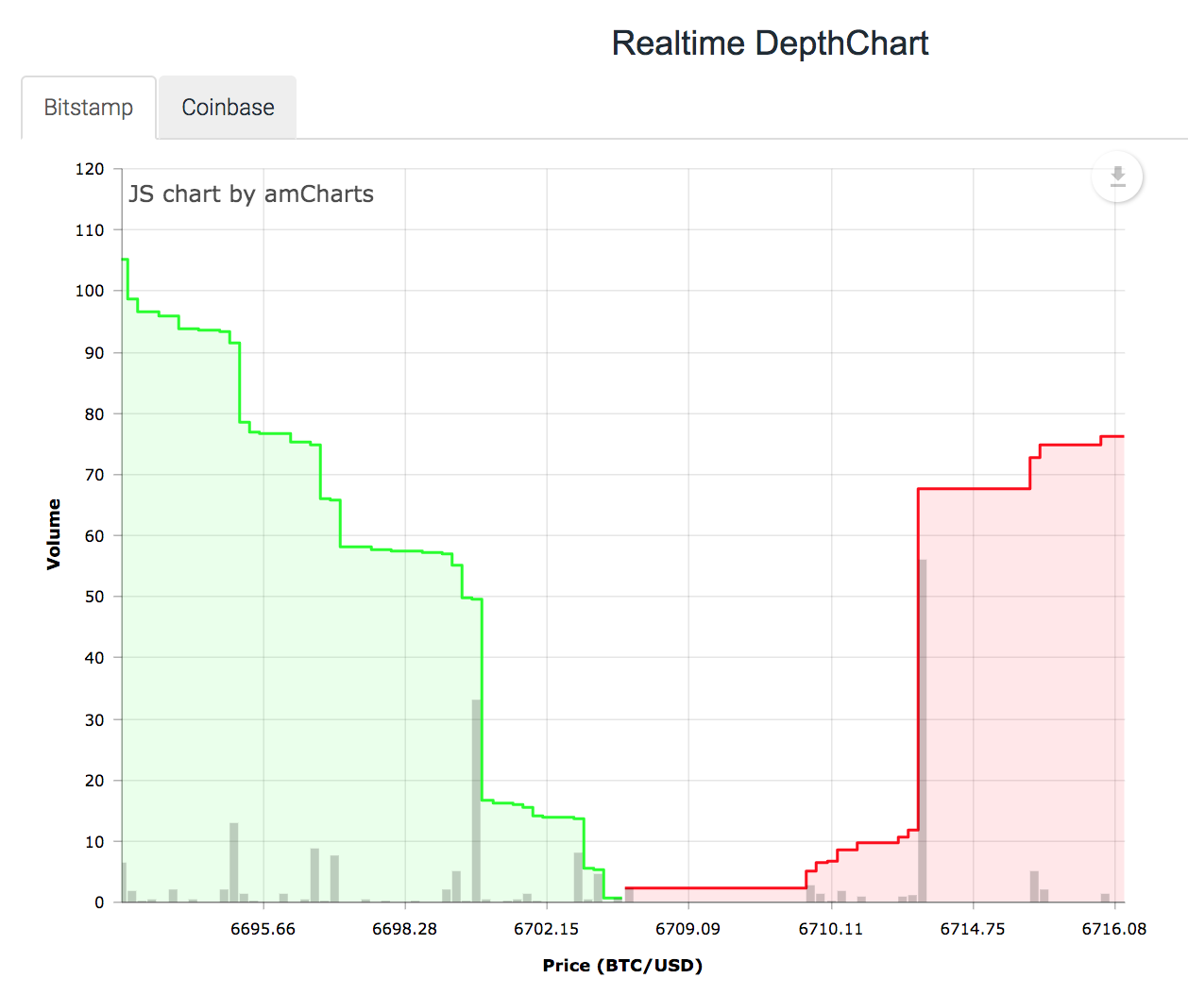

Figure 13 depth chart

The depth chart is transforming the live information of orders into line chart, which is focus on the volume of each price. From the chart, customers can easily tell the bid/ask with high/low volume, based on which they can make decisions on investment, such as which price has larger potential to be made sooner, which price has larger possibility to be filled in later.

## 4.4 Insight page

The insight of trending is another feature of the website. The “whales” refer to a purposive group who wants to manipulate the market (called ‘whales’) or by the individuals who place orders around a same price.

Investors used to look at the depth chart and order book trying to find the relation between supply and demand in cryptocurrency market, while there is a limitation that investors would not know who is behind the buy wall or sell wall. If the market is not reasonably robust, it potentially can be manipulated by the whale. Therefore, we adopt the whale watching algorithm created by Paul Jeffries (2018), and modify it to be embedded in our website. As shown in figure 14, the whale is indicated in the chart by bubble or ladder, where the bubble indicates that there is one large order has been placed (e.g. 500 BTC for sale at $9000 via 1 unique order), and the ladder indicates that there are a few small size orders has been placed for identical volume at increasing prices (e.g. 500 total BTC for sale by 10 unique 50 BTC orders starting from $9000 and to $10000). The size of bubble or ladder reflects the whale size which is the order size, and there are whales in both ask and bid orders. The x-axis is the order size, and y-axis means the order price, the whale chart updates timely and presents the latest possible whales in the market. The investors can check the whale chart before buy in to see if there are big funds controlling the market.

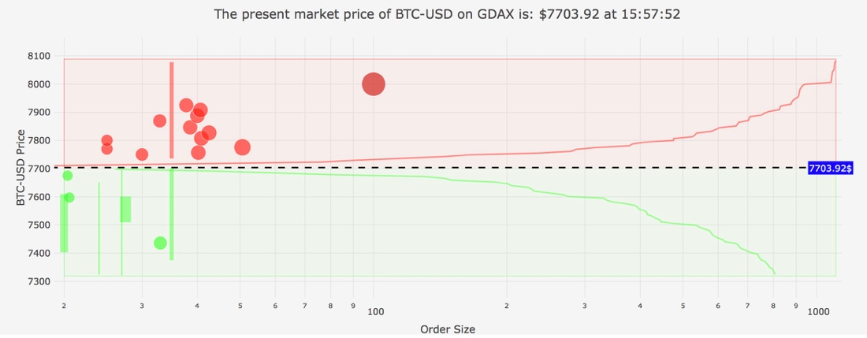

Figure 14 Insight of trending

To summarize, the website is the main deliverable of this project. It is an information integrating website which covers most of the statistics for cryptocurrency investors and contains various kinds of data visualization. These data visualizations aimed to give client a comprehensive perception on cryptocurrency and an enjoyable experience through browsing the website.

# 5. Methodology

## 5.1 Backend & Data access

In this website, the pages are separated according to the function, and the history rates are easily accessed via API provided by exchanges, data from GDAX and Bitstamp is accessed for comparison of volume and currency price.

Real-time order book requires another type of data access API called WebSocket feed, it is indicated in figure 16 that WebSocket feed does not utilize the request/response strategy, it opens a connection and keep feeding the up-to-date data, the connection can remain opening before a client request it to close (John, 2017). WebSocket feed can provide data more efficiently and stable

1) Data persistence

Django framework is used for backend of the website, as Django has superior advantage in administration of models. The beginning of this project is to create the backend framework and connect models to database. The connection to database is simple, by configure the database parameters in the setting file. Besides, the Django framework has connected to database, and the build command in the table of database that Django will use have been created.

The database used in this project is MySQL as it is a free software and is convenient for student project. The Django migrate command is used to migrate the model to database and create tables after the finishing the model. As mentioned above in the deliverable, only the daily history data is stored in database. Thus, there are 6 tables in database, storing the history rate of 3 cryptocurrencies from 2 different exchanges. The model needs to specify all the data type of the accessed data from API, Figure 15 shows all the tables stored in database for this project.

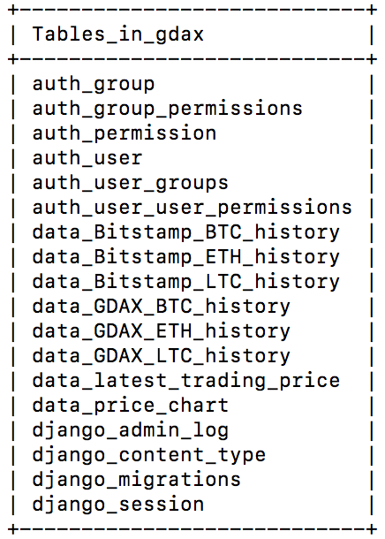

Figure 15 tables in database

Our source data can be accessed via GDAX and Bitstamp API, and persisted in MySQL database. All the historical rates of 3 currencies from 2 exchanges are daily data, so a method is written to have history data update automatically every day.

2) Data models

As mentioned in above section data persistence, the data model included in this project is only the historical rates of 3 different cryptocurrencies from 2 exchanges, and the data is accessed via GDAX and Bitstamp API, while the data type from 2 different exchange is a slightly different, the data from Bitsatmp has the attribute volumeto which is the total capacity of a certain period, as the GDAX do not provide such statics, the project ignore the capacity as it cannot be compared with GDAX data. The data model involved in this project stored in database is shown in Table 8. Other data models include model used for testing, the latest trading price is for testing if the business logic in views can return the last accessed data in order book, and price chart model is to test the data feeding from backend to frontend.

|  |  |  |
| --- | --- | --- |
| Model name | Attributes | Data access API |
| Data_Gdax_BTC_history | Time (Date)  Low (Decimal)  High (Decimal)  Open (Decimal)  Close (Decimal)  Volume (Decimal) | Gdax_getProduct(BTC-USD) |
| Data_Gdax_LTC_history | Time (Date)  Low (Decimal)  High (Decimal)  Open (Decimal)  Close (Decimal)  Volume (Decimal) | Gdax_getProduct(LTC-USD) |
| Data_Gdax_ETH_history | Time (Date)  Low (Decimal)  High (Decimal)  Open (Decimal)  Close (Decimal)  Volume (Decimal) | Gdax_getProduct(ETH-USD) |
| Data_Bitstamp_BTC_history | Time (Date)  Low (Decimal)  High (Decimal)  Open (Decimal)  Close (Decimal)  Volume (Decimal) | Min-API(BTC-USD) |
| Data_Bitstamp_LTC_history | Time (Date)  Low (Decimal)  High (Decimal)  Open (Decimal)  Close (Decimal)  Volume (Decimal) | Min-API(LTC-USD) |
| Data_Bitstamp_ETH_history | Time (Date)  Low (Decimal)  High (Decimal)  Open (Decimal)  Close (Decimal)  Volume (Decimal) | Min-API(ETH-USD) |
| Data_price_chart | Title (Varchar)  Shape (Varchar)  Time unit (Varchar)  Prices (iterator<Varchar>)  Time (Date)  Low (Decimal)  High (Decimal)  Open (Decimal)  Close (Decimal)  Volume (Decimal) | History data from database |
| Data_latest_trading_price | Time (Date)  Price (Decimal) | Gdax websocket feed |

Table 1 Data models

3) Data feeding

the business logic is established after the model is created and completion of backend framework, the business logic includes retrieving data from API, updating data, storing the data at database and passing the data to frontend pages. The business logic is written in the views of the Django framework. The logic for accessing data and displaying the data was initially written in the same method, it results in the longer loading time of the website, and the backend developer optimize the algorithm and separate the data access and data update from the data feeding, when loading the history page, it just need few seconds to get data from the local database.

The last job is to connect the backend with the frontend pages, it is accomplished by returning JSON response to react the request from frontend. The URL path required to be set in the backend as well.

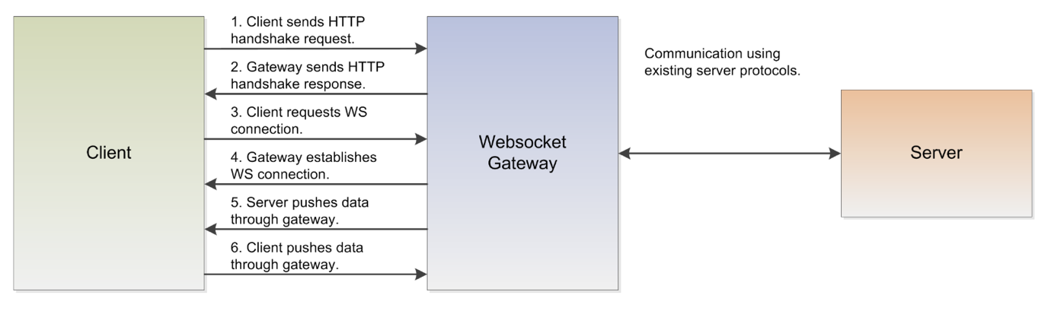

Figure 16 Websocket feed

## 5.2 Frontend

At the initial stage, we would like to use some popular frontend frameworks like Angular or React for their appealing features, while later we found out that those frameworks also brought extra burdens, for instance, the compatible issues with other libraries, and requiring serialization between them and Django. Therefore, we left them behind and build the frontend using HTML, JavaScript, and CSS with some lightweight toolkit like jQuery, and Bootstrap. For generating various charts, amCharts, EChart, and Plotly are adopted as visualization tools in this project. As mentioned above, we acquire data through APIs or WebSocket, and it will be loaded by the visualization tool, then execute processing and calculation. At last the processed data will be visualized to the browser.

## 5.3 Whale chart

The current version of whale-discovering function is for GDAX, the support for other exchange platform will be completed in future work. There are 2 types of whale will be presented in the whale chart: bubble whale and ladder whale, and only the orders that constitutes more than 1% of the volume of the order book portion will be visualized. To plot the whale chart, Dash framework and Plotly library are applied for data processing and visualization.

Firstly, the raw data will be acquired through WebSocket; then pre-process the data by sorting, rounding, filtering, and calculating; After that store the data into three main tables, vol_grp_bid, vol_grp_ask, and final_tbl, of which first two are for ladder whale and the last one is for bubble chart. The reason for that bubble whale needs only 1 tables is bubble whale is about one large order at a single price point, and it is feasible to append ask price table to the end of the bid price table. The following tables will show the important attributes.

|  |  |
| --- | --- |
| **vol_grp_bid/ vol_grp_ask** | |
| ‘unique’ | Size of the order |
| ‘count’ | Number of the order |
| ‘min_price’ | Minimum price in this ladder whale |
| ‘max_price’ | Maximum price in this ladder whale |
| TBL_VOLUME | Total volume of the orders |
| ‘total_price’ | Total price of the orders |
| ‘text’ | The summarized text for the ladder whale |

Table 2 vol_grp_bid/vol_grp_ask attributes

|  |  |
| --- | --- |
| **final_tbl** | |
| TBL_VOLUME | Size of the order |
| TBL_PRICE | Price of the order |
| ‘n_unique_orders’ | Number of the unique orders |
| ‘total_price’ | Total price of the orders |
| ‘text’ | The summarized text for the bubble whale |
| ‘sqrt’ | The square root of the TBL_VOLUME, to be used to determine the size of the bubble |
| ‘colorintensity’ | Calculated by ‘n_unique_orders’, to be used as shade factor of colours |

Table 3 final_tbl attributes

Now it is ready to plot the chart, the 2 figures below show the code snippets. When the visualization is done, multiple thread method will be applied to handle multiple WebSocket connections.

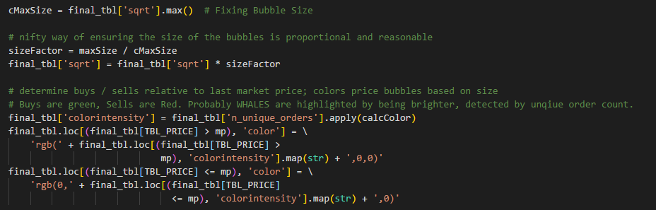

Figure 17 Bubble whale code snippet

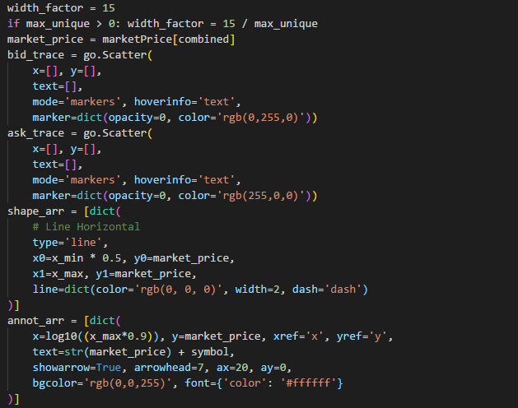

Figure 18 Whale chart background code snippet

## 5.4 Collaborating methods

Agile software development

Our 4-people team performs fairly flexibly and this project could be quite open, therefore, Agile software development is suitable for this project. We focus more on human interaction rather than red tape. Brainstorming, exploring, and achieving have been more important detailed paperwork.

## 5.5 Hardware & Software

Hardware

The application will run on python as to be implemented in all modern operating system (Windows, macOS). Basically the Web page is designed to be accessed via computer. Later version of the website will be mobile optimized.

The hardware involved in this project will be 4 MacBook laptops as well as the lab computers in School of IT. The computers are used to write the code and provide localhost service when testing. All the database will be created and held on private computers.

Software

All the software technologies that have been used to complete the project are listed below:

1. PyCharm

2. WebStorm

3. Anaconda navigator

4. Tomcat server

5. Github for version control

6. Slack for group communication

The software used in the development of the project is selected by the group member after the comparison with other similar software. Pycharm is an excellent choice of developing environment as it consists of features like code completion and hinting as well as code navigation (Kennedy, 2015). WebStorm is another IDE built by JetBrains, mainly for web development. Anaconda navigator is to download and manage the external libraries or packages and frameworks for Python, Django framework can be installed easily via Anaconda navigator.

Other software including Tomcat, Github and Slack are very popular and common softwares for web application designing. These software can make the project more professional and official. These software are either open source software or free software, which is the best choice for the capstone project.

# 6. Evaluation and Reflection

## 6.1 Evaluation

After multiple weeks of development and discussions, our team has completed a reasonably quality deliverable, in this section, the evaluation would be conducted, which is based on the requirements of the project outline, user requirements and team proposal.

Basically, what we have done and delivered in this project is a website that retrieves and stores data from cryptocurrency exchanges into MySQL database where the data model designed by ourselves. Furthermore, it visualises and analyses these data to provide comprehensive information to the clients. The section of deliverable provides detailed functions and features of this project.

According to the project description, “In this project, students will retrieve, store, and visualize data from various cryptocurrency exchanges. Students will also employ data modelling techniques to find suitable data‐structures to represent order books of exchanges, will store them in a relational database, and visualize them via a web‐interface using java‐script.” (quote from project description), the deliverable has sufficiently satisfied the requirements of the description that is considered as our customer specifications.

In the previous sections, we have discussed the business requirements. Based on the requirements, client features and user experience design, user requirements could be summarized in following points.

1. The user’s interaction with website should be friendly and should have short learning curve.

2. The data should be accurate and legit.

3. The visualization should be meaningful, reliable and enjoyable.

4. The respond and loading time should be short and stable.

Therefore, to assess the website with the listed requirements, the website could be considered as a success. To be specific, first, the principle of the website design is simple, neat and intuitive. The team has managed to minimize the misunderstanding and increase the interaction efficiency to meet the principle. For example, the team has designed and implemented the “product selector” to change the cryptocurrencies that the chart is presenting. One selector could control several kinds of charts. Besides, the website has four web pages, each page has its own theme which presents one segment of cryptocurrency information. The segmentation is clear and smart enough for users to differentiate without any information redundancy and gap. Second, all of our data are retrieved from legit and credible source such as Restful API and WebSocket from Bitstamp or Coinbase, and credible data supplier-cryptocompare. Third, the website uses line chart, candlestick chart, depth chart and its derivative-whale chart, which are commonly used and well-crafted to demonstrate data intuitively to users. According to the independent test result, the samples show that there is no obstacle for users to understand the content which graph is trying to provide. Furthermore, the API used to draw charts are reliable API from major chart API providers such as Baidu amCharts and HighCharts, the risk of chart dysfunction is very low. However, the response speed could be improved. The current loading time of real-time page and insights page is longer than we expected sometimes, it depends on the user’s network status, because those pages use web socket as data feed. If user has hard time on internet connection, maybe the response time would take longer than it supposed to take.

Overall, the website provides sufficient functions and services to meet different kinds requirements, it could be considered as a successful product to locate and solve user’s problems.

## 6.2 Reflection

### 6.2.1 Website reflection

For this project, the team has delivered a workable website, however, it is a promising product that is worth further improvements, especially in the cryptocurrency industry which has inherently intense information load and rapid changes.

Thus, considering the nature of the website and the business requirements, we have designed and planned the future improvements.

1) Currently, the website has just one special insight analysis function, the whale chart. However, users may need more insight to persuade themselves to place the orders. In order to help users, get more comprehensive understanding of the market, more statistical conclusion would be preferred. It could be cryptocurrency performance indicator such as which kind of cryptocurrency has the biggest increase or decrease in last week. Furthermore, cryptocurrency news could be integrated in this website, which would provide more diversified information for users. The news would be organised and verified, so that it would become an accessible and reliable crypto expert for users. Furthermore, unlike numbers and statistical data, news of cryptocurrencies would provide more intuitive evidence for users.

2) In the website, the whale chart is indicating anomalies and interruptive market changes. However, the problem is that users have to stay online get the information, if they don’t focus on the website, the information might be missed. Therefore, more methods should be developed to remind users to get the information. For that purpose, we planned to use email or SMS as additional reminder of the whale chart. Users will need to log in the website and set their own parameter for reminder. If the condition meets the parameter, a reminder would be sent through email or SMS. It would save substantial time and effort on staring at the screen and would prevent users from losing market opportunities.

3) Due to the technical barrier and time limitation, the website still can be enhanced in some aspects. For instance, the response time could be improved in the later version, algorithms and scripts would be updated. Furthermore, the website is now using bootstrap as a tool for mobile platform supporting, in the future, more detailed and reliable design for mobile platforms would be released online.

4) After careful selection, we have decided to use Bitstamp and GDAX because they have the best credible market reputation and reliable data souring API. But two exchanges are not enough. In the future, we are going to change our exchange filtering conditions to bring more reliable exchanges to the website.

### 6.2.2 Project Management reflection

To look back the whole development process, it took us lots of efforts and we have learnt a lot not only on the development skills but also project management skills. Here are some project management problems we have faced.

1) Inexperienced developers. The group have few experience on web development and make some wasted efforts on inappropriate tools. Fortunately, all members now have clear understanding of web development.

2) Poor project scope management. Since there is no such a client in this project, we did not perform well on project scope management. One of the major problems we have faced is lack of clear, specific, and attainable objectives. The objectives and milestones have been changed during the development process.

Therefore, based on the issues we have met, we have designed a set of solution to improve our project management level.

1) Leadership and Quality Control. More leadership are essentially required in future work. A good leader help keep on track of the project success, and guarantee the project quality.

2) Clear Focus and Objectives. We need ensure the plan is executed to achieve project goals defined in the project scope, and avoid vague or nebulous objectives.

3) Improved Communicative Skills. The communication between clients and project team, and that within the team are equally important.

# Conclusion

CryptoDemyth is a synthesize website providing cryptocurrency trading information via data visualization. Users can check and compare the exchange rates among BTC-USD, LTC-USD, and ETH-USD form GDAX and Bitstamp. Additionally, users can discover insight form the market trend by spotting the whale in cryptocurrency market. The development group has been working on how to help investors in a way that others cannot do. Though current version of the website is not perfect, the future work will fix up. Through the development process, we also realized that profoundly understanding of the essence of tech stack and good project management will lead to project success.

# Reference

1. Coinmarketcap.com. (2018). *Cryptocurrency Market Capitalizations | CoinMarketCap*. [online] Available at: https://coinmarketcap.com [Accessed 10 Apr. 2018].
2. Litecoin.org. (2018). *Litecoin - Open source P2P digital currency*. [online] Available at:

https://litecoin.org/ [Accessed 10 Apr. 2018].

1. Sornette, D., & Sanadgol, D. Design and implementation of a software system for the composition of a database and automated trading system on different cryptocurrency trading markets.
2. Bouri, E., Molnár, P., Azzi, G., Roubaud, D., & Hagfors, L. I. (2017). On the hedge and safe haven properties of Bitcoin: Is it really more than a diversifier? *Finance Research Letters, 20*, 192-198.
3. Corbet, S., Larkin, C., Lucey, B., Meegan, A., & Yarovaya, L. (2017). Cryptocurrency Reaction to FOMC Announcements: Evidence of Heterogeneity Based on Blockchain Stack Position.
4. Li, X., & Wang, C. A. (2017). The technology and economic determinants of

cryptocurrency exchange rates: The case of Bitcoin. *Decision Support Systems, 95*, 49-60.

1. Bigby, G., 2018. *How to Evaluate the Quality of Your Website Design.* [Online]   
   Available at: <https://dynomapper.com/blog/19-ux/188-how-to-evaluate-the-quality-of-your-website-design>
2. John Mueller. 2017. What Is a WebSockets Push-Styled API and How Does It Work?. [ONLINE] Available at: <https://www.programmableweb.com/news/what-websockets-push-styled-api-and-how-does-it-work/analysis/2017/04/20>. [Accessed 19 June 2018].
3. Jeffries, P. (2018). Github Repository. Retrieved June 1, 2018, from <https://github.com/pmaji>